Science at Hillside

Subject Leader: Miss McCann
Subject Support Coach: Miss Nelson
Link Governor: Mr Such

Vision and principles:
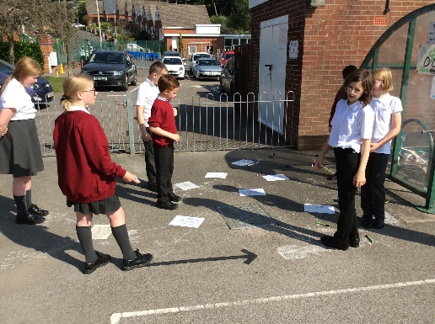
At Hillside, we are determined to provide a stimulating science curriculum that enables children to understand, explore and question the world around them and find out why things happen in the way that they do. We aim to nurture the natural curiosity of every individual at Hillside through teaching methods of enquiry and investigation to stimulate creative thought, scientific knowledge and vocabulary. Through inspiring and relevant lessons, children engage in practical experiences where they develop both the skills required to work as a scientist (disciplinary knowledge) and the scientific knowledge (substantive knowledge) to understand, share ideas and ask scientific questions to answers the many ‘wonders’ they may have. Extra enrichment/wider opportunities enable children’s science learning to extend and continue beyond the classroom to build up their science capital and understanding of the relevance of science in contextualised real life situations in the wider world, which ensures our children begin to appreciate the way in which science will affect the future on a personal, national and global scale.
The following are the principles of Science teaching at Hillside, decided and agreed by the children and staff on the way we feel Science should be taught to everyone.
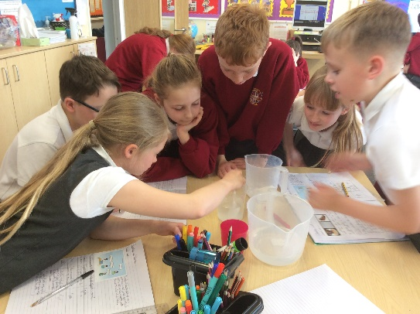
Good Science at Hillside:
Hands on practical and investigative
Inspiring, engaging and relevant
Led by questions and ‘wonders’
Loved by teachers and pupils
Sharing ideas and developing curiosity
Is linked to other subjects
Developed outside of the classroom
Encourages enquiring minds

These principles are displayed in every classroom as part of the Science working wall.

Subject leader
As Science lead at Hillside Primary, my role is to lead, develop and support Science across the school in relevant and innovative ways, to ensure all teachers have the subject knowledge, skills and confidence to deliver interesting and challenging lessons. This high quality teaching enables children to experience high quality science opportunities and experiences. Within my role, I also take responsibility to ensure that I am equipped to lead the subject effectively and confidently, providing training and support to staff and ensuring wider opportunities are provided for all children outside of the classroom.
I feel it is essential that children understand the relevance of science to the wider world and their own experiences. Where possible, Science is linked to other curriculum to demonstrate links across the subject areas but still retaining its importance as a core subject.
Science at Hillside is taught through practical lessons wherever possible, developing the skills of working scientifically and enquiry based learning, supported by subject specific knowledge and vocabulary, all of which become increasingly challenging as pupil progress through the school. (mapped out on the progression grids).
I am a confident and knowledgeable subject leader, mainly due to the extensive CPD opportunities I have received over the past year through the STEM centre, local cluster groups and my involvement as a Science Influencer in the ‘Science Across the City’ project within Stoke on Trent. As a qualified facilitator, I also have the skills required to ensure that my knowledge is disseminated effectively to staff back at school. In addition I have achieved the accreditation of CSciTeach and PSQM outreach.
My own passion for science stems back to high school, where the practical aspect engaged my interests and this continued through college and eventually university, where I obtained my degree in Biological Science. This personal love of the subject leads me to believe that with scientific thinking and an enquiring mind, our children can enter the world looking for answers and making a difference to their futures and the futures of the next generations.

Curriculum
The objectives for Science in EYFS, KS1 and KS2 are clearly set out for each year group in the EYFS Framework and the National Curriculum.
Statutory framework for the early years foundation stage (publishing.service.gov.uk)
Science programmes of study: key stages 1 and 2 (publishing.service.gov.uk)
The national curriculum for science aims to ensure that all pupils:
- develop scientific knowledge and conceptual understanding through the specific disciplines of biology, chemistry and physics
- develop understanding of the nature, processes and methods of science through different types of science enquiries that help them to answer scientific questions about the world around them
- are equipped with the scientific knowledge required to understand the uses and implications of science, today and for the future

Curriculum design

We teach Science in EYFS as an integral part of the topic work covered during the year. Ongoing scientific experiences and opportunities are planned from the objectives set out in the EYFS Framework, which underpin the curriculum planning for children age 3 - 5. Understanding the World ensures children develop early scientific ideas and processes through hands on activities, practical exploration and outdoor experiences.
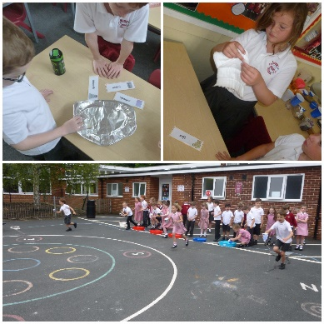
The Science curriculum is planned both progressively and through cross-curricular links where relevant, to ensure the children are engaged in purposeful and meaningful learning which supports and enhances other curriculum areas. The topics have been intentionally mapped out throughout KS1 and 2 to ensure the progression and development of skills, knowledge and vocabulary over time to develop knowledgeable and skilled scientists.
Curricular links with Science
English

There are many opportunities across all year groups for children to further develop their English skills through their science learning. Speaking and listening is an integral part of the way that science is taught at Hillside and children are encouraged to ask and answer questions and discuss observations made. Writing opportunities are planned to enable children to apply their skills for a range of purposes. For example:
Writing non chronological reports about the topic studied, writing explanations of phenomena observed, recording findings using scientific vocabulary with accuracy, designing menus for animals, writing in response to a letter received asking for advise, writing a diary to record the growth of a plant.

Mathematics

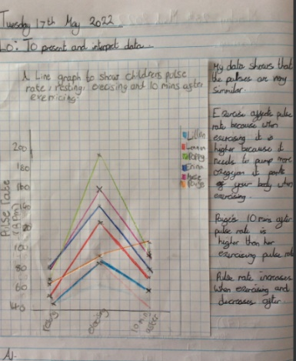
Maths naturally has clear scientific links, and through their learning, children are using and applying mathematical knowledge in examples such as:
Creating tally charts to collect data, presenting data through block graphs and bar charts, using Venn diagrams to sort and classify objects/animals/materials, using measures to carry out investigations, reading scales when using scientific equipment, understanding temperatures and negative numbers, producing line graphs from the collection of continuous data.

Computing
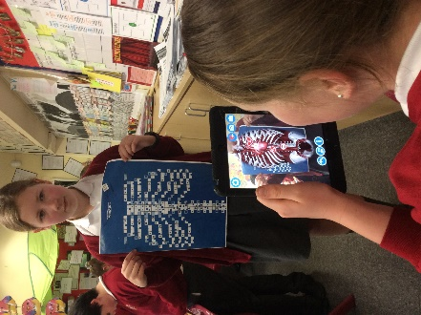
Computing enhances our teaching of Science wherever appropriate in all key stages. The children use computing in a variety of ways such as researching using secondary sources, word processing, and presenting information via PowerPoint. Collection of data using data logging apps, and the use of scientific apps such as Virtualitee, Science Journal and Plantsnap also support working scientifically skills. Opportunities to support science learning and recording through Purple Mash are utilised wherever appropriate.

Design and Technology

As part of our curriculum planning, science and DT links are increasingly evident. Many science objectives are now being developed and applied through the DT projects within in each year group. Examples of these links include: applying knowledge of a healthy eating through the food technology projects, considering properties of materials when working with structures mechanisms and textiles in KS1. KS2 links include: applying their understanding of the nutritional value of foods, observing reversible and irreversible changes and considering balanced diets during food projects, applying their understanding of circuits during the electrical systems projects and understanding the properties of materials when designing and making structures.

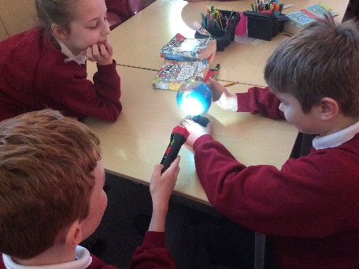
Geography

Children reinforce their geographical knowledge and understanding when learning about topics in Science including: habitats and climates, states of matter and the water cycle, Earth, sun and moon and time zones and seasons, including the northern and southern hemisphere. Links with the social responsibility strand of Geography also provides opportunities for children to appreciate and understand how environments and habitats can be impacted upon.

History
As part of each unit of science, children are introduced to significant scientists from the past who have contributed and worked in that particular area of science. They learn about the impact that individuals from the past have had on developments in science and that scientific ideas are constantly changing as time passes. The cross-curricular links made in the design of the science curriculum ensures that it supports topics such as ‘The Great Fire of London’ in KS1.

SMSC

SMSC experiences occur naturally within science across all Key Stages.
Spiritual development is enriched by providing many opportunities for children to think and spend time reflecting on the amazing wonders which occur in our natural world. Our extensive outdoor area ensures our children spend quality time outdoors during science lessons, where they are encouraged to be in touch with nature when being involved in lessons related to habitats and living things.
To promote moral development, children are taught to show care and consideration to environments and the world in which we live. In addition, they are encouraged to understand that different opinions need to be respected and valued, including discussions about environmental and human issues, and that not all scientific developments are valued by all.
Social development is promoted through science, through the understanding of the power of collaborative working within the science community with scientific advances. They are taught about how to keep safe when working within science and how findings from others can shape further developments for themselves and others.
Additionally, children’s cultural development is enriched through class visits, connections with online scientists, when looking at how scientists have had a significant impact globally, and also involvement in extra-curricular science events and opportunities, such as the Great Science Share for Schools.

Growth Mindset

Growth Mindset teaching supports our children in developing their can-do attitudes The learning completed during these lessons embeds the knowledge that children need to work hard, persevere and challenge themselves in order to achieve. Science reinforces the growth mindset of the children through asking and finding the answers to questions, learning new knowledge and skills, planning and carrying out a range of enquiries and being determined to find answers to ‘wonders’ they may have. By developing these essential life skills, children can see that, with perseverance and a positive growth mindset, they have the skills they need, and that they can grow their skills to succeed.

Careers

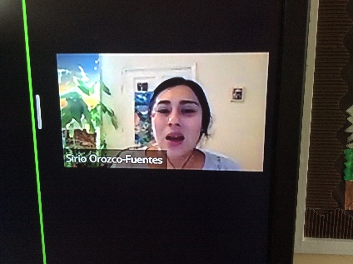
At Hillside, there are many opportunities for the children to develop their understanding of science related careers. The enrichment opportunities are closely planned around promoting a love of STEM subjects and we regularly provide links with career opportunities through learning about scientists, both traditional and contemporary through lessons, including meeting scientists through the STEM ambassador program. We have held ‘dress as a scientist day’ where children are encouraged to dress as ANY occupation that would use science in their jobs, including nail technicians, marine biologists, sports coaches etc.

Assessment for learning

Assessment in Science is carried out both formatively during each lesson and summatively in order to gain an understanding of the children’s achievements and the next steps for their progress. Opportunities for assessment are planned into lessons for elicitations of ideas and misconceptions of knowledge and working scientifically skills. Assessments are carried out in various forms, including observing, questioning, discussions and end of unit reflections, as appropriate to the age of the children and the nature of the topic. The assessment system provides concise information about each pupil within school in a way that is effective, relevant and manageable to all staff and allows tracking of each individual child’s progress as they move on their journey through Hillside.

Enrichment

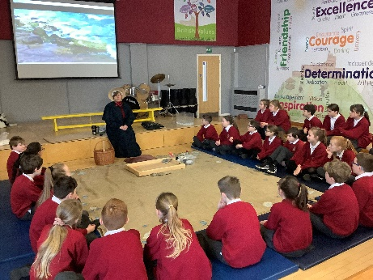
In addition to the EYFS and NC objectives being delivered to the children, there are many other enrichment and wider opportunities provided to enable children to engage with science and to promote and enthuse the passion for science across the school. Annual events include: science themed trips, science enrichment visits for the more able and talented children, involvement in national science projects and programs such as involvement as a judging panel for The Royal Society Book Prize, visiting the Big Bang Science Fair in addition to other enrichment activities during science week. Other events have included an after school forest schooling science club and a science fair for all pupils. Events vary on a yearly basis.

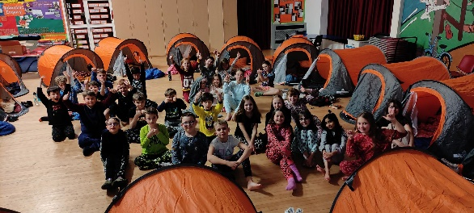
We place great importance on educational visits and visitors to enhance the Science curriculum. These visits allow our children to make connections to what they have learned in class and secure their understanding of the topics through first hand experiences. Children in each year group experience a Science themed visit over the year. These may include visits to Hoo Farm, Peak Wildlife Park, Jodrell Bank, Coombes Valley Nature Reserve, The National Space Centre and the Museum of Science and Industry and we also hold an annual onsite residential Space Camp.

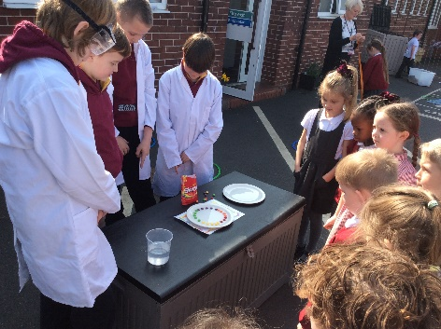
Science ambassadors are employed from Year 6 to plan and carry out their own demonstrations and investigations for the KS1 children to be involved in, in order to enthuse and excite them and encourage a love of Science from a young age.

Homework to support scientific thinking, talking and questioning is set half termly. All children across the school are provided with a photo and a question to promote discussion at home, with parents and siblings. Awards are presented to the best ‘scientist’ of the month providing an age appropriate response. Responses are then displayed to enable then to be shared. Key Stage Two children also have a research task to find out about a significant scientist and we also encourage parents to celebrate any science carried out at home, which is displayed on photos within school.

Pupil Voice
Science has been prioritised over the last few years to ensure the high profile it deserves as a core subject, has been achieved. The children talk about science with enthusiasm and excitement, which was evident during the most recent pupil voice carried out:
‘Science is amazing because you get to go into the woods to find things out.’ Year 1 child
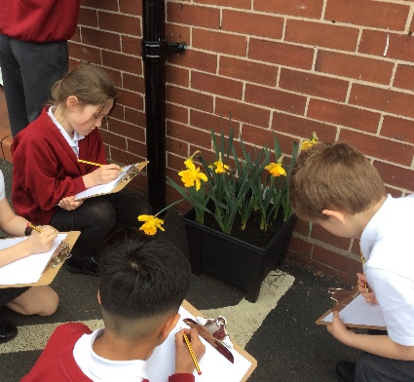
‘Science helps us to learn about everything there is in the world, without science, you wouldn’t have any answers’ Year 4 child
‘I find science really interesting because it involves so much information, but it is all interesting as we get to carry out investigations and enquiries all the time.’ Year 6 child
‘We always get to be involved in our learning and I love using all of the equipment to collect our results’ Year 5 child.

